GEMS, MINERALS, AND BONEYARD

Lindsey Berkowitz, Western High School

Savion Mercedes, Plantation High School

Piero Salini, Coral Springs Charter School

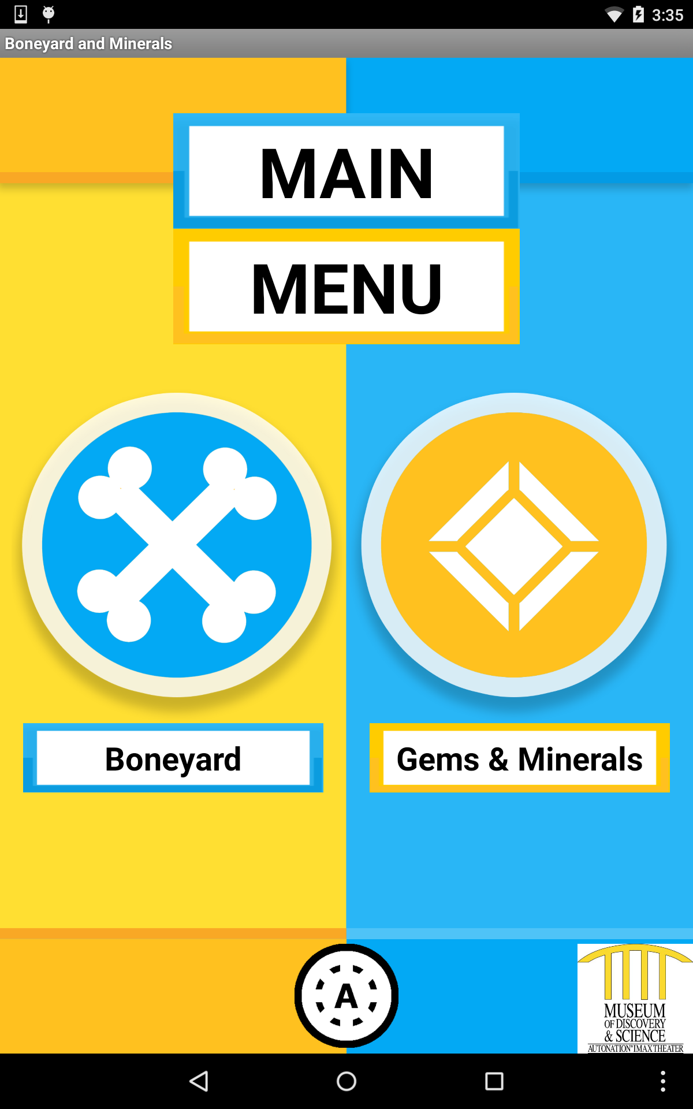

ABSTRACT

Our app goes over the mineral & boneyard exhibit with more detail presented in respects to the actual assets of said exhibit.

BACKGROUND

The museum of discovery and science acting as facilitator of a new coding internship, accepted a variety of exemplary student applicants as coming from a multitude of Broward County schools. Being accepted to the program was an award in itself due to now being able to more readily or extensively learning coding and its related branches in addition to now also being able to use our experiences to better our own skills and capabilities.

Introducing ourselves to the museum itself and to its array of exhibits was one of the first activities that was then conducted. Afterwards we then had to decide upon groups and thus what exhibit projects we wanted to undertake and transfer into app form.

Our group in particular had decided upon the upstairs minerals & boneyard exhibit because we wanted to encourage further appreciation of and interest in a frequently forgotten or ignored area. This exhibit looked kind of plain and was lacking in textual depth but due to its possession of many aesthetically appealing gems and minerals, we felt that a translation into a very graphically and informational focused app may make greatest use of the exhibit’s assets.

Then for the next several months we participated in various preparatory meetings and museum discussions for the development of our app. Whether it was hanging up planning posters in order to devise a preferred concept or just talking over what we needed to implement or utilize, we all mentally strived to further our concepts while performing our responsibilities & activities. We continued with this, be it at the museum or at home, well until the FAU class started.

METHODS

We, the Gems/Minerals & Boneyard group, were divided into 3 different branches: User Interface, Graphics and Java.

Piero Salini (User Interface) and Savion Mercedes (Graphics) worked together to design the layout of the entire application as well as implementing the corresponding graphics. When the layout was agreed upon by User Interface and Graphics, every single detail was passed onto Piero to be put together, which was then sent to Lindsey. All the graphics, except for the minerals, which were labeled for reuse, were originally created by Savion Mercedes. Using adobe Photoshop to create and design them, he was able to implement a wide variety of aesthetic quirks and principles into the app. Additionally, the graphics and the app design itself draws inspiration from a number of exemplary galleries and artistic sources. So the graphics in its entirety has been hopefully created to appeal to many people or users.

Lindsey Berkowitz was the skeleton of our app, connecting all of our pages together to make it function. Using java as the code to make the XML files interactive, Lindsey was able to string together the pages by creating buttons to launch activities. Even with background experience in java coding, there was still a lot left to learn, which is where the help of the teacher assistants and peers came in. With the wonderful help of our respective teachers at FAU, we were able to use the knowledge passed onto us to develop the app. One of the methods used to solve our problems for Java and User Interface were trial and error. Since we have never operated on Android Studios before we figured a few things out ourselves. Although our teachers taught us many useful things, some other things were a bit

RESULTS

Our app with primary focuses on both graphics and information, was created to provide information on what we felt was missing or inadequate all while also trying to strengthen the exhibit through another viable outlet. Organizing the totality of the exhibit into two main sides: minerals & boneyard, we were able to better present rather large bulks of information that became further divided sections and icons, each with their own respective materials. In addition to general information for the majority of the app, the mineral section also comes with a simple matching game.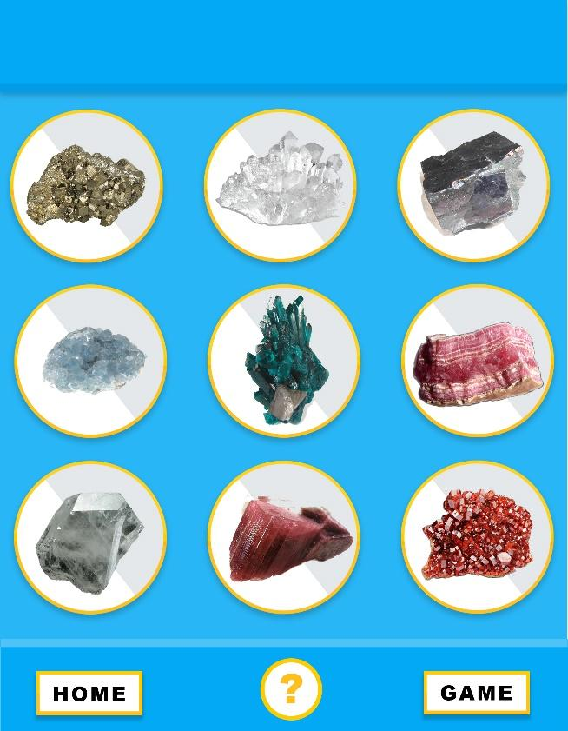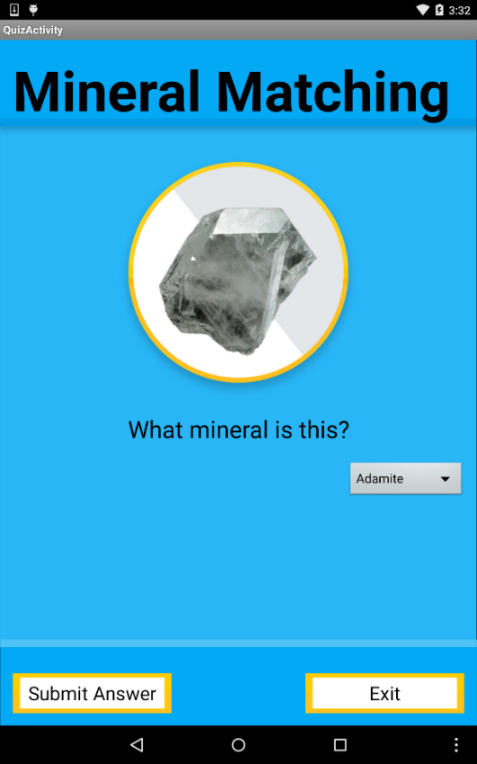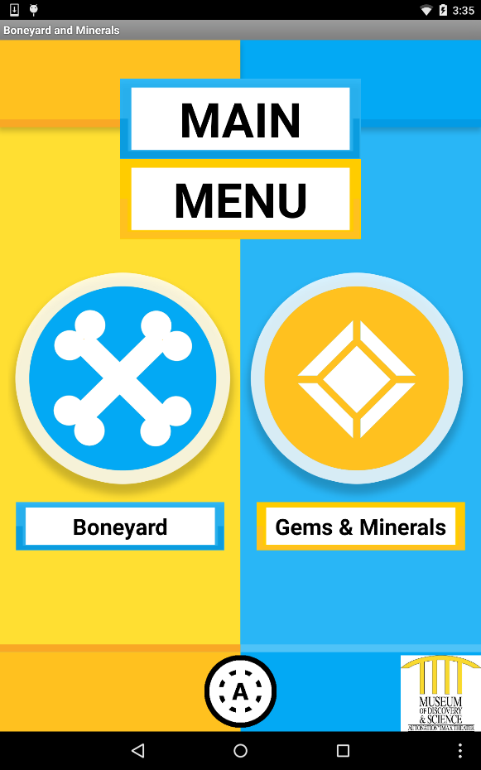

DISCUSSION

Despite that the app was completed for the most part, we still would’ve loved to implement some additional features or adjustments into it. Some of these items include the implementation of side-scrolling features into the main view of the minerals section or just music and sounds wholly throughout the app. We still also need to adjust the entirety of the app, such as just debugging some parts of it or adjusting the code within the linking between sections.

CONCLUSION

In conclusion we feel as though we accomplished much during our time attending the FAU class with near full completion of our app project. We really feel content with how our app visually looks and how it functions for the most part as we believe that it is easily navigable with a simplistic but extensive flow. We of course don’t feel fully satisfied and beyond with what we have produced but most people aren’t. Work takes a lot of time and effort, which we can hopefully to spend more of in the future to fully accomplish what we started but as of now, we feel that our FAU coding class experience has really opened up our minds, views, and own capabilities as well.

ACKNOWLEDGEMENTS

* Museum of Discovery & Science
* Florida Atlantic University
  + Dr. Shankar
  + Prof. McAfee
  + Dr. Mitsova-Boneva
  + AlainEdwards
  + Santiago
  + Demetrius
* Broward College
* Google Design
* Adobe
* Android Studios
* Online Databases
  + Wikimedia
  + Wikipedia
  + Webmineral
  + Google Images

REFERENCES

* Wikimedia
* Wikipedia
* Webmineral
* Google Images
* Google Design